Desktop Keyboard
Feel-good typing that's built to go the distance

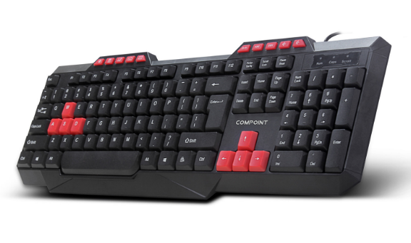

Descrption:

Multimedia control and gaming shortcuts

The new CP-K6015 is a fully functional, low profile full-size keyboard designed for better multimedia functionality for common activities such as email, sounds, skip tracks and of course browser control.

Furthermore the CP-K6015 has colour-coded keys for the most common gaming control, both on the cursor pad and also the alpha keys, meaning faster key recognition and thus faster gameplay thrown in.

Ideal for tablet and mobile computing devices..

Being totally Plug n' Play, the CP-K6015 keyboard is also compatible with AndroidTM tablet devices which have a USB port available (or via a on-the-go adapter), which makes typing faster and or course more accurate than touching a screen. Its also ideal for the RaspberryTM PI computer, whereby a low-cost but multifunction keyboard is required.

Features:

Comfortable type with tactile feedback

Extended multimedia shortcut buttons

Colour-coded popular gaming action keys

USB Plug n' Play - for WindowsTM, MacTM, LinuxTM and PITM

Specifications
- material :ABS material
- Port：USB
- Cable: 1.5M lenght
- Low-profile, quiet keys
- Full-size keyboard
- Thin-profile keyboard
- Spill-resistant design
- Durable keys that can last
- up to 10 million keystrokes
- Strong, adjustable tilt legs
- Plug-and-play USB connection
- Bold, bright characters
- No software installation
- Certificate: CE FCC ROHS
- Operating Temperature:0℃ to +45℃
- Operating Humidity:10%0 to 85 % RH
- Storage Temperature : -10℃ to +55℃
- Storage Humidity: 5% to 90 % RH

Product Code:
Part number: K6015
Barcode: 8400800034595
Size: 43.5X14.5X2 cm
Weight: 0.380 kg

